**Cuizine:**

Biryani

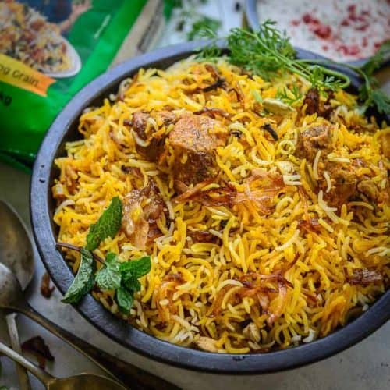

**Biryani** , also known as **biriyani**, **biriani**, **birani** or **briyani**, is a mixed rice dish that originates from the Hindu of the Indian subcontinent. This dish is especially popular throughout the Indian subcontinent, as well as among the diaspora from the region. It is also prepared in other regions such as Iraqi Kurdistan. It is made with Indian spices, rice, meat (chicken, goat, beef, prawn, or fish), vegetables or eggs. *Biryani* is a Hindustani word derived from the Persian language, which was used as an official language in different parts of medieval India by various Islamic dynasties. One theory states that it originated from *birinj*, the Persian word for rice. Another theory states that it is derived from *biryan* or *beriyan*, which means "to fry" or "to roast.